Github link: <https://github.com/Amrutha-J822/CMPE_272_Lab02>

1. VM1 and VM2:A screenshot of a computer

   Description automatically generated
2. Running the ansible playbook:A screenshot of a computer

   Description automatically generated
3. VM1 public IP: 54.183.228.161
4. VM2 public IP: 18.144.3.58
5. VM1 output:A screenshot of a computer

   Description automatically generated
6. VM2 output: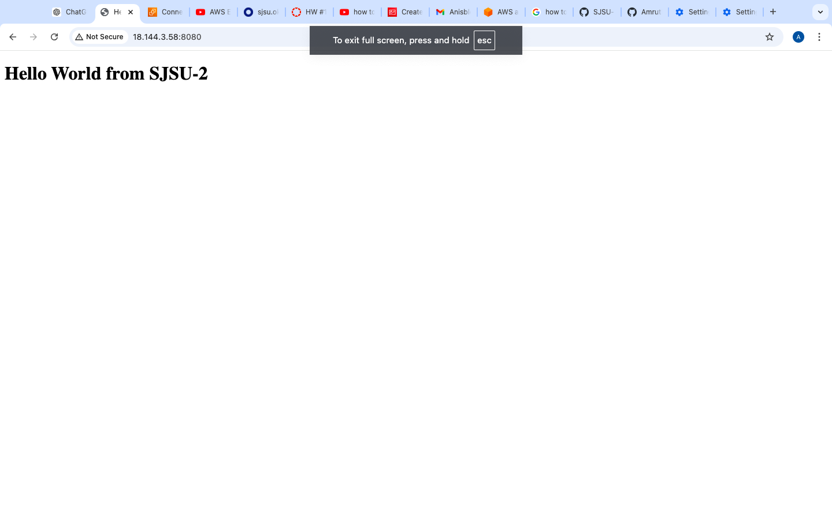
7. Undeployment: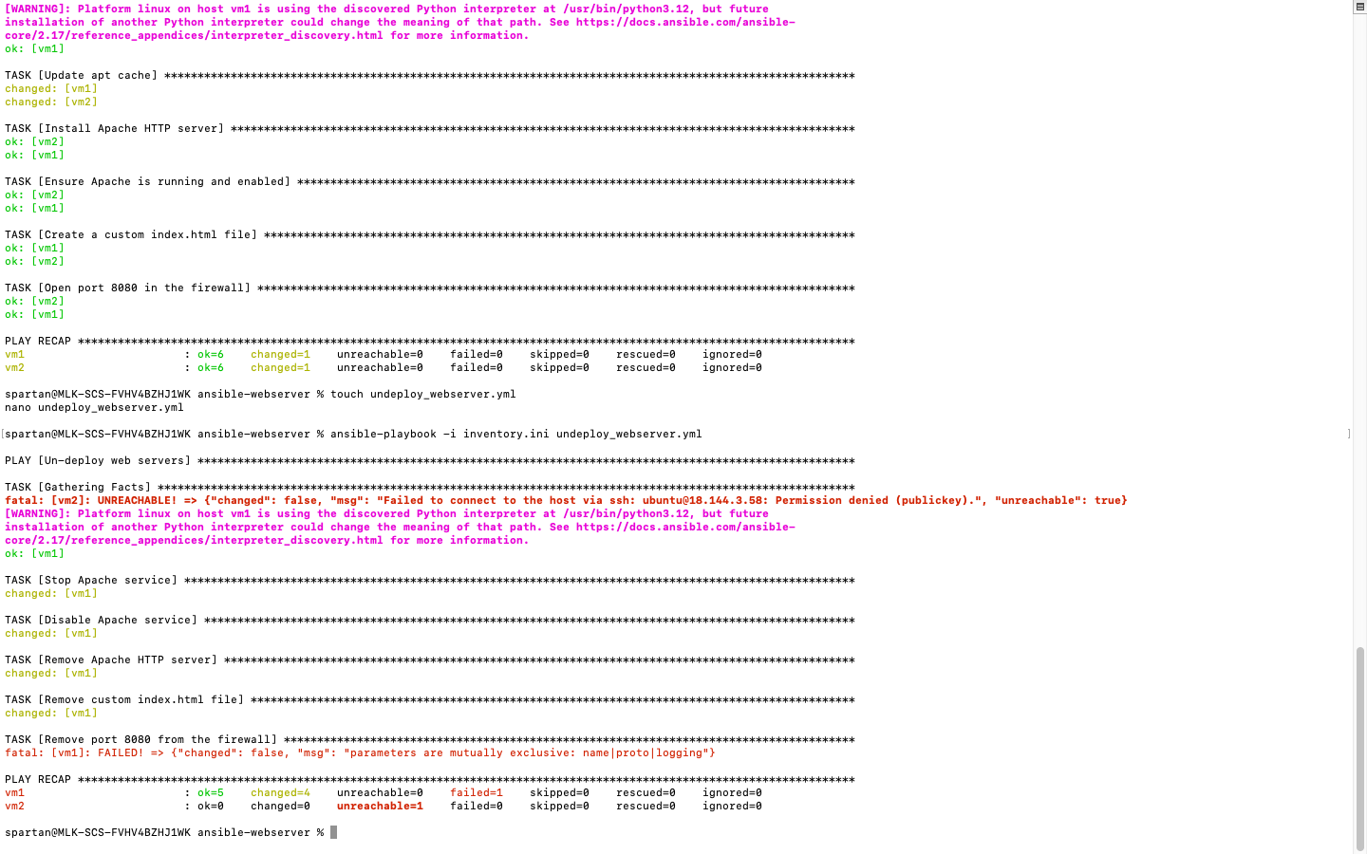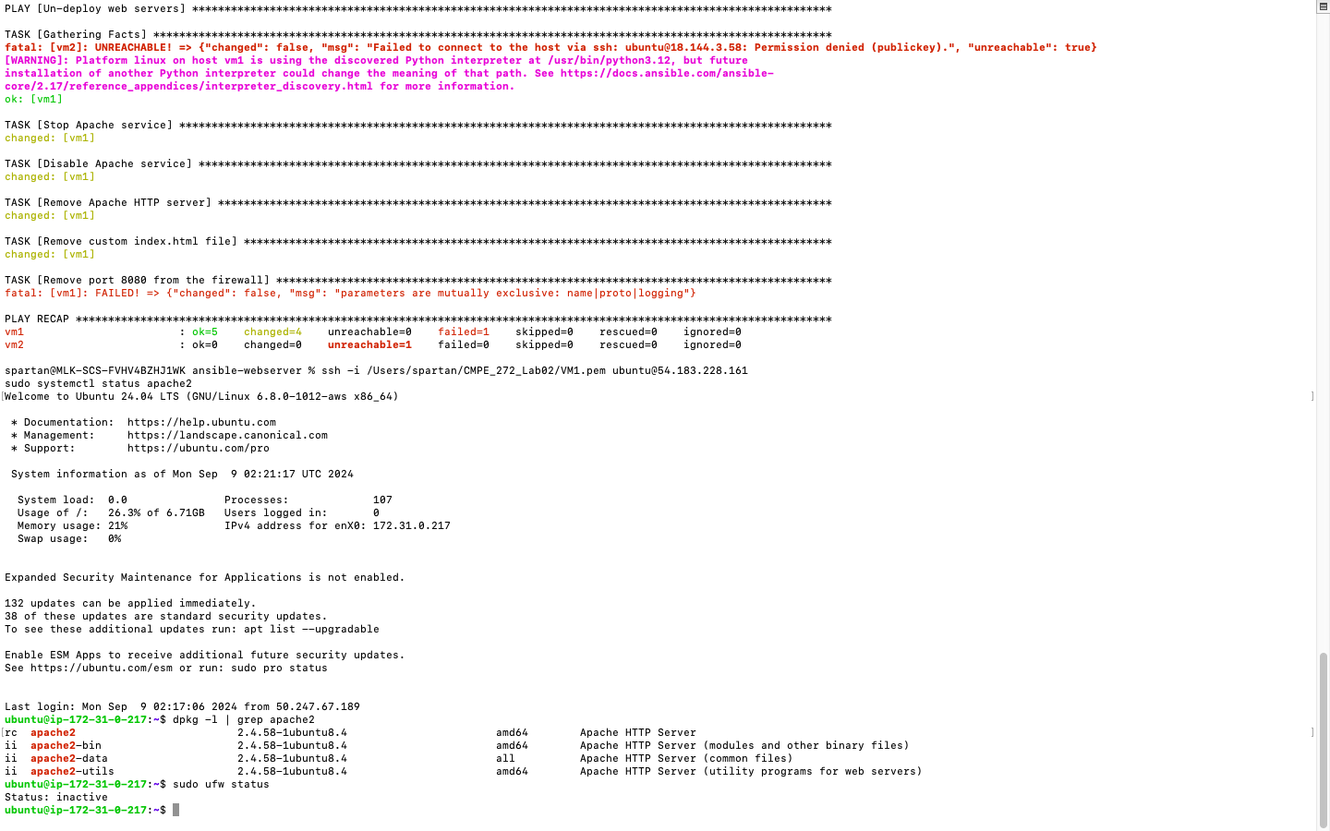
8. VM1 undeployment: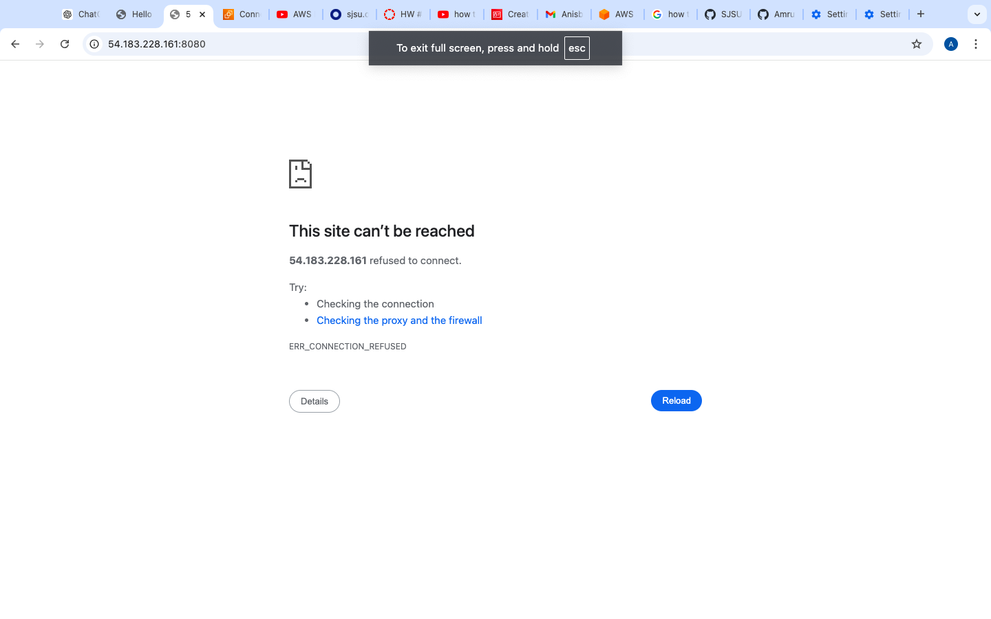
9. VM2 undeployment: